When you come the manager dashboard using url manager screen will show

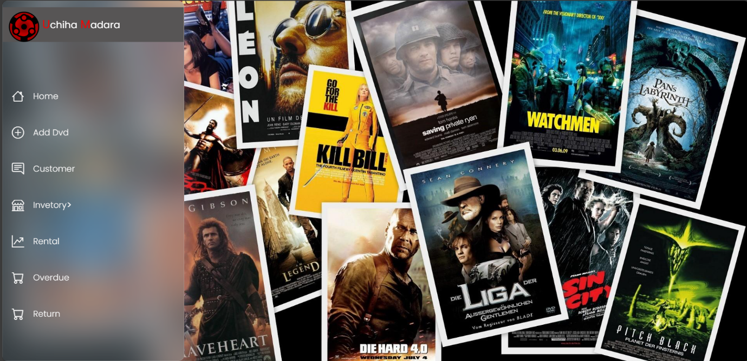

When you clik the add dvd you can add dvds you can recive the msg of adding it

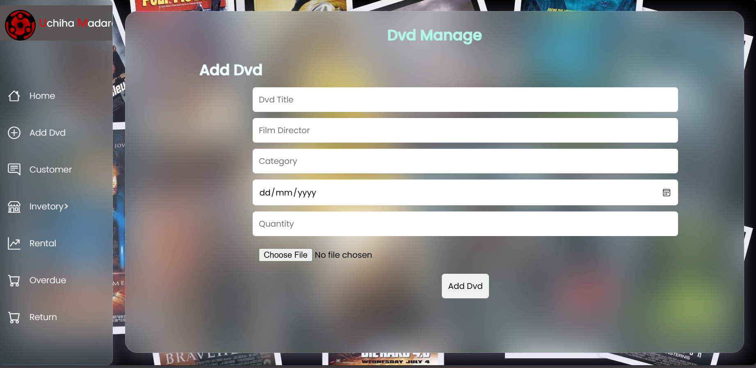

When you click the customer you see the customers details

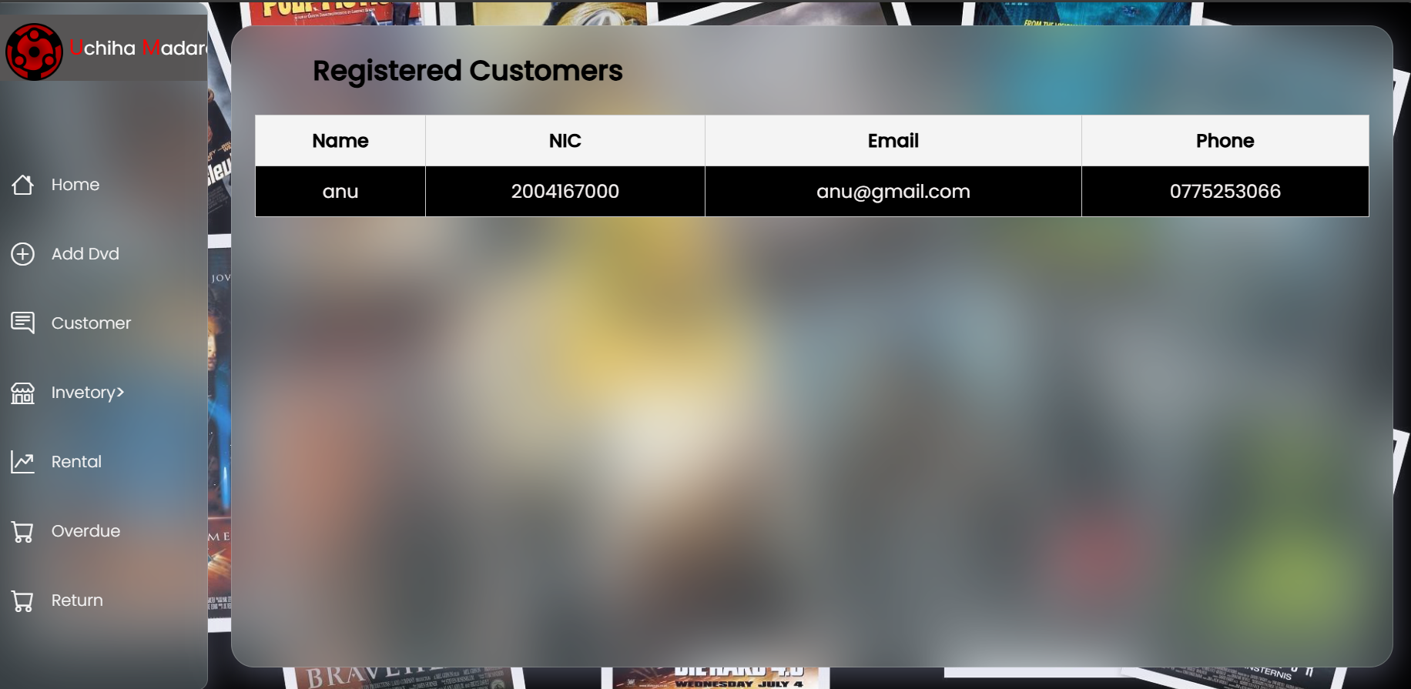

When you click the inventory you can see your add dvds list

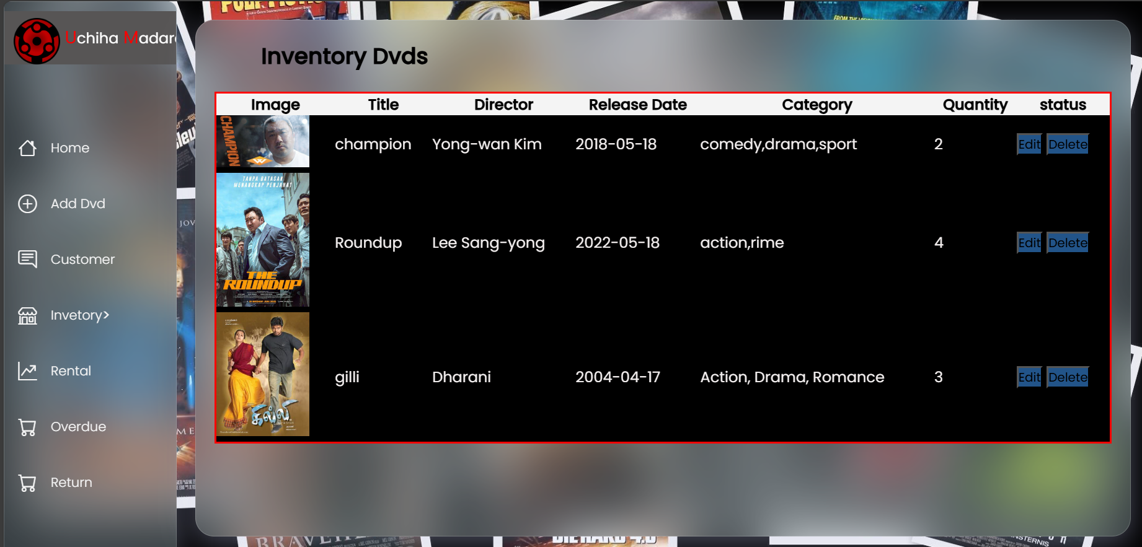

When you click the home



Other buttons are not available but empty tables only show